Streams:

Streams are collection of data, they wouldn’t be available all at once as they may not fit into the memory, streams are used when working with the large amounts of data, we need to process one chunk at a time.

stream-demo.js

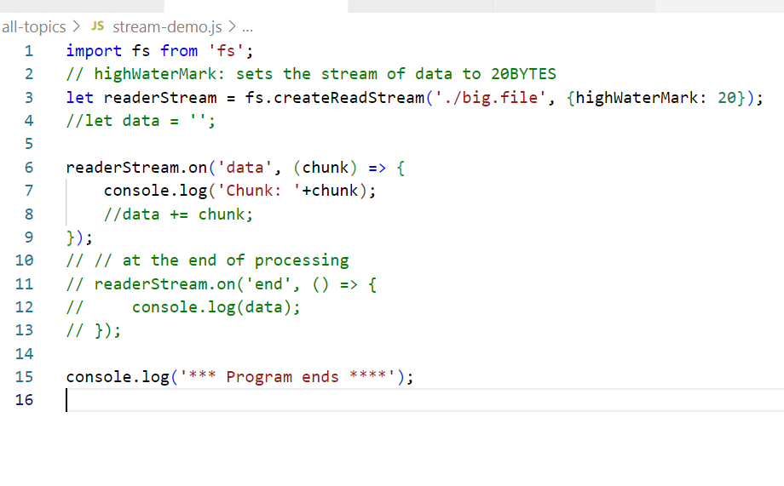

Output:

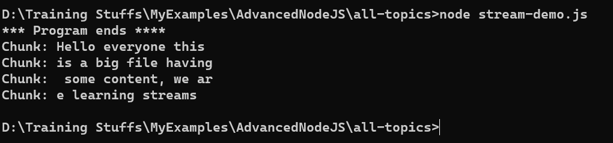

We can also pause the stream & resume, let us use some counters and timers to do that

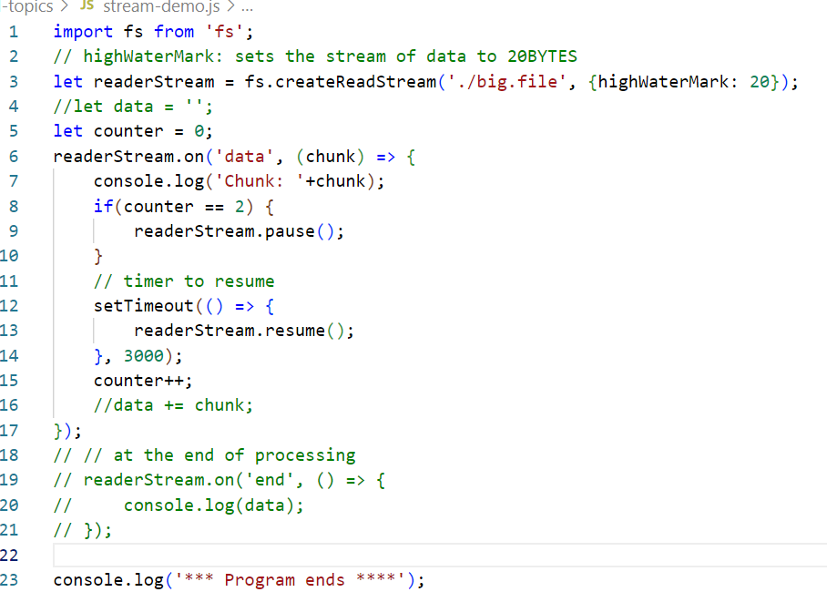

Output: You see some more chunks after 3s

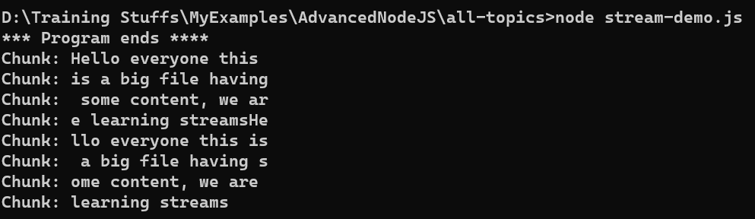

Streams 101

There are four types of streams.

1. Readable streams: fs.createReadStream() to read the streams
2. Writable streams: fs.createWriteStream() is to write the streams
3. Duplex streams: Can read and write streams, tcp socket is an example of Duplex streams
4. Transform streams: When you read & write the streams you want to modify while reading & writing, example of transform is the compressing of data streams, like zip files

Buffers

A buffer is way to store and manipulate binary data, usually when the data’s are passed over the network in the binary form we need Buffer to manipulate store and manipulate them, it could be binary streams or authorization headers having base64 data.

